Articles Determiners

🔹 What Are Articles (a type of determiner)?
# Source: AI Source: Provided by: [Data Path: Persons Table -> ID Column: 1, Name_En Column: Motasem Essam] -> From: [Chatgpt (GPT-4-turbo)] on [7/28/2025]
Articles are a type of determiner used before nouns to show whether the noun is specific or general.
They help indicate which person or thing we are talking about.

✅ Types of Articles
# Source: AI Source: Provided by: [Data Path: Persons Table -> ID Column: 1, Name_En Column: Motasem Essam] -> From: [Chatgpt (GPT-4-turbo)] on [7/28/2025]
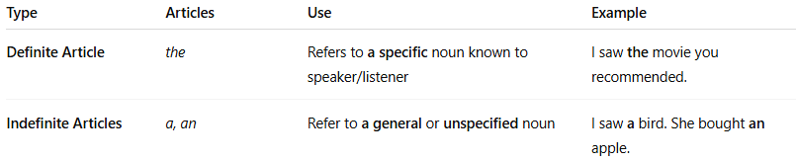
Type | Articles | Use | Example
Definite Article | the | Refers to a specific noun known to speaker/listener | I saw the movie you recommended.
Indefinite Articles | a, an | Refer to a general or unspecified noun | I saw a bird. She bought an apple.

📚 Rules and Usage
# Source: AI Source: Provided by: [Data Path: Persons Table -> ID Column: 1, Name_En Column: Motasem Essam] -> From: [Chatgpt (GPT-4-turbo)] on [7/28/2025]
- Use “a” before words that begin with a consonant sound:
→ a car, a teacher, a hotel
- Use “an” before words that begin with a vowel sound:
→ an apple, an hour, an umbrella
- Use “the” when the noun is already known, unique, or specified:
→ the sun, the teacher we met, the only option

📝 Example Sentences
# Source: AI Source: Provided by: [Data Path: Persons Table -> ID Column: 1, Name_En Column: Motasem Essam] -> From: [Chatgpt (GPT-4-turbo)] on [7/28/2025]
- I found a book on the shelf. (any book, not specific)
- She adopted an elephant from the sanctuary. (vowel sound)
- The book you lent me was great. (specific book)

